**DAILY ONLINE ACTIVITIES SUMMARY**

|  |  |  |  |  |  |
| --- | --- | --- | --- | --- | --- |
| **Date:** | | **30/06/2020** | **Name:** | **JASLINE SHARON TAURO** | |
| **Sem & Sec** | | **4th sem, A Section** | **USN:** | **4AL18CS029** | |
| **Online Test Summary** | | | | | |
| **Subject** | **----** | | | | |
| **Max. Marks** | **----** | | **Score** | **----** | |
| **Certification Course Summary** | | | | | |
| **Course** | | Cloud Support Engineer | | | |
| **Certificate Provider** | | **AWS Educate** | **Duration** | | **3 hrs.** |
| **Coding Challenges** | | | | | |
| **Problem Statement:**   1. Write a C++ Program to Move all zeroes to end of array using Two-Pointers. 2. Write a C Program to check whether the number is Ugly or not. 3. Write a C Program to generate first n Ugly Numbers. | | | | | |
| **Status: EXECUTED** | | | | | |
| **Uploaded the report in GitHub** | | | **YES** | | |
| **If yes Repository name** | | | <https://github.com/jaslinesharontauro/C_Prgms> | | |
| **Uploaded the report in slack** | | | **YES** | | |

Online Test Details: (Attach the snapshot and briefly write the report for the same)

Certification Course Details: (Attach the snapshot and briefly write the report for the same)

Coding Challenges Details: (Attach the snapshot and briefly write the report for the same)

CERTIFICATION COURSE DETAILS:

 Today I completed the final assessment of the course “DevOps Engineer” by AWS Educate and received the badge for the same. And also started the new course “Cloud Support Engineer” by AWS Educate. In this I studied about platforms and completed the assessment of this module.

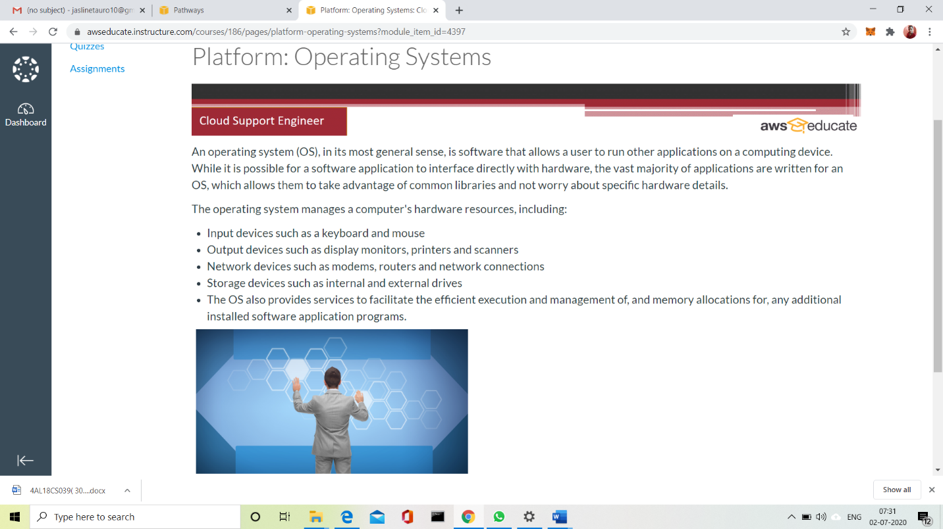

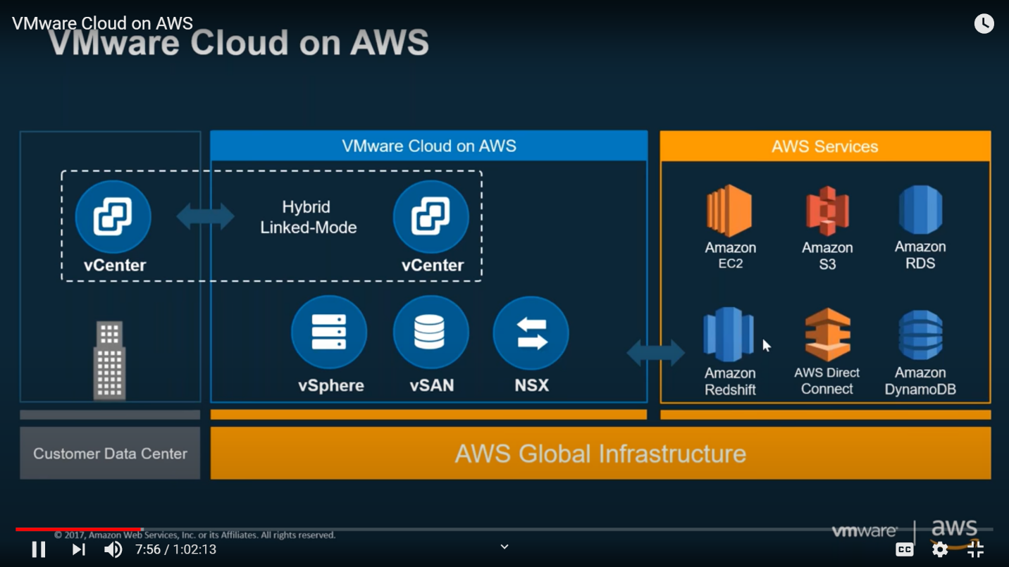

WEBINAR DETAILS:

Today I have attended the webinar on “Input and Output in C++, Syntax and structure of C++ program, Class and Object, Static member function and member data” by Assistant professor Ms. Shruthi Shetty J, CSE department- AIET. There was quiz conducted based on the webinar. The quiz was of MCQ type, there were 6 questions of 5 mark each. I scored 30.

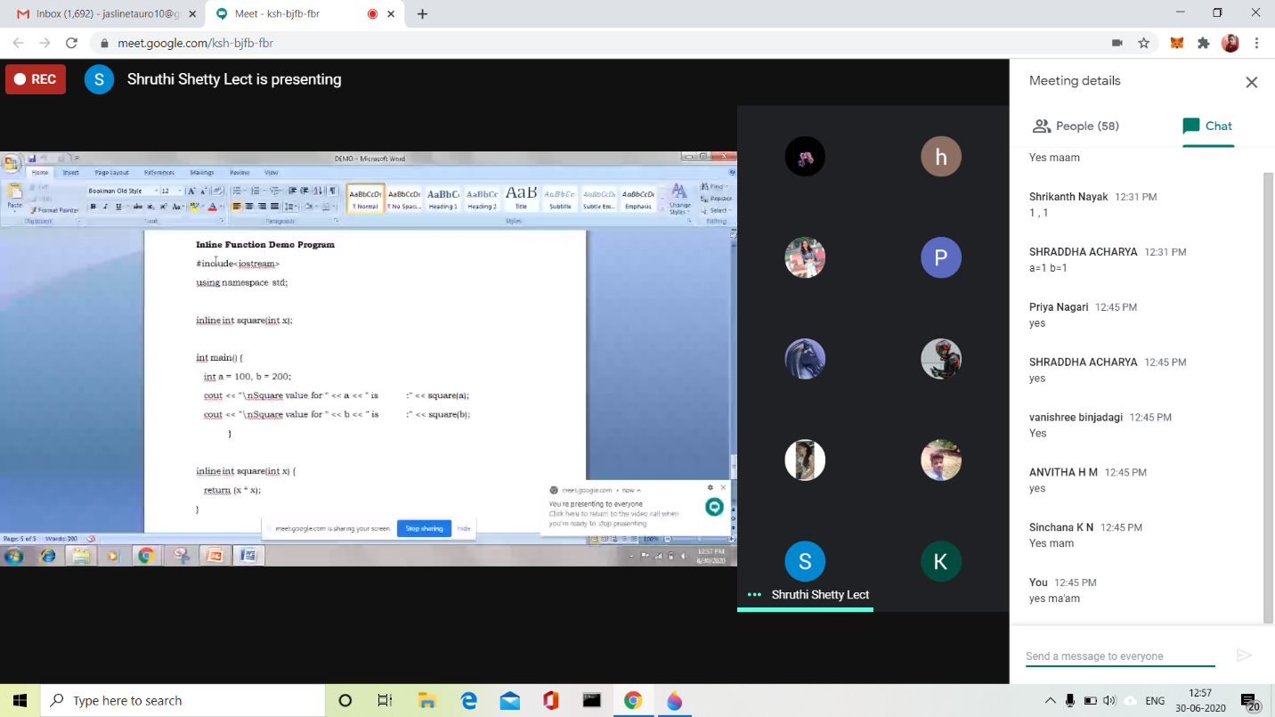

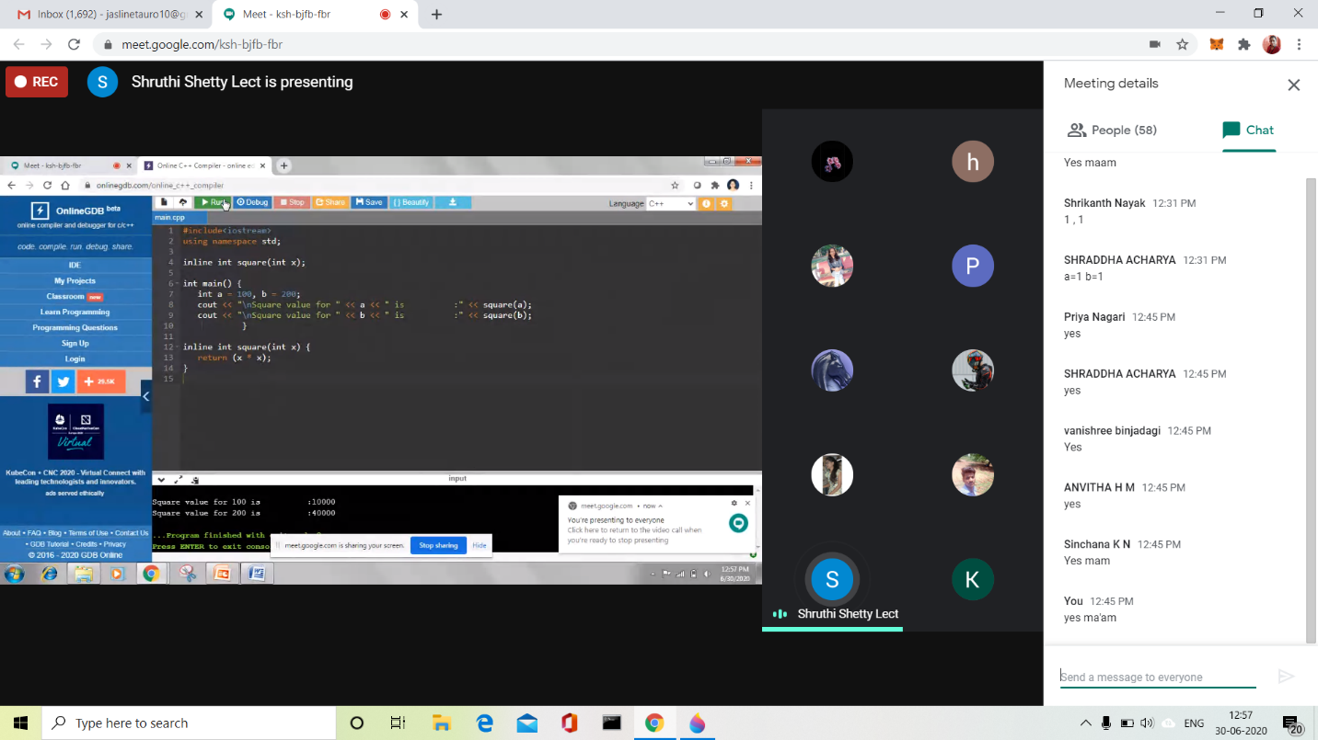

CODING CHALLENGES:

Problem Statement 1:

Write a C++ Program to Move all zeroes to end of array using Two-Pointers

Given an array of random numbers, Push all the zero’s of the given array to the end of the array. For example, if the given arrays is {1, 0, 2, 6, 0, 4}, it should be changed to {1, 2, 6, 4, 0, 0}. The order of all other elements should be the same.

Examples:

Input: arr[]={8, 9, 0, 1, 2, 0, 3}  
Output: arr[]={8, 9, 1, 2, 3, 0, 0}  
Explanation:  
Swap {0 ,1} -> Resulting array {8, 9, 1, 0, 2, 0, 3}  
Swap {0 ,2} -> Resulting array {8, 9, 1, 2, 0, 0, 3}  
Swap {0 ,3} -> Final array {8, 9, 1, 2, 3, 0, 0}

Input: arr[]={4, 5, 0, 0, 0, 0, 6, 7}  
Output: arr[]={4, 5, 6, 7, 0, 0, 0, 0}

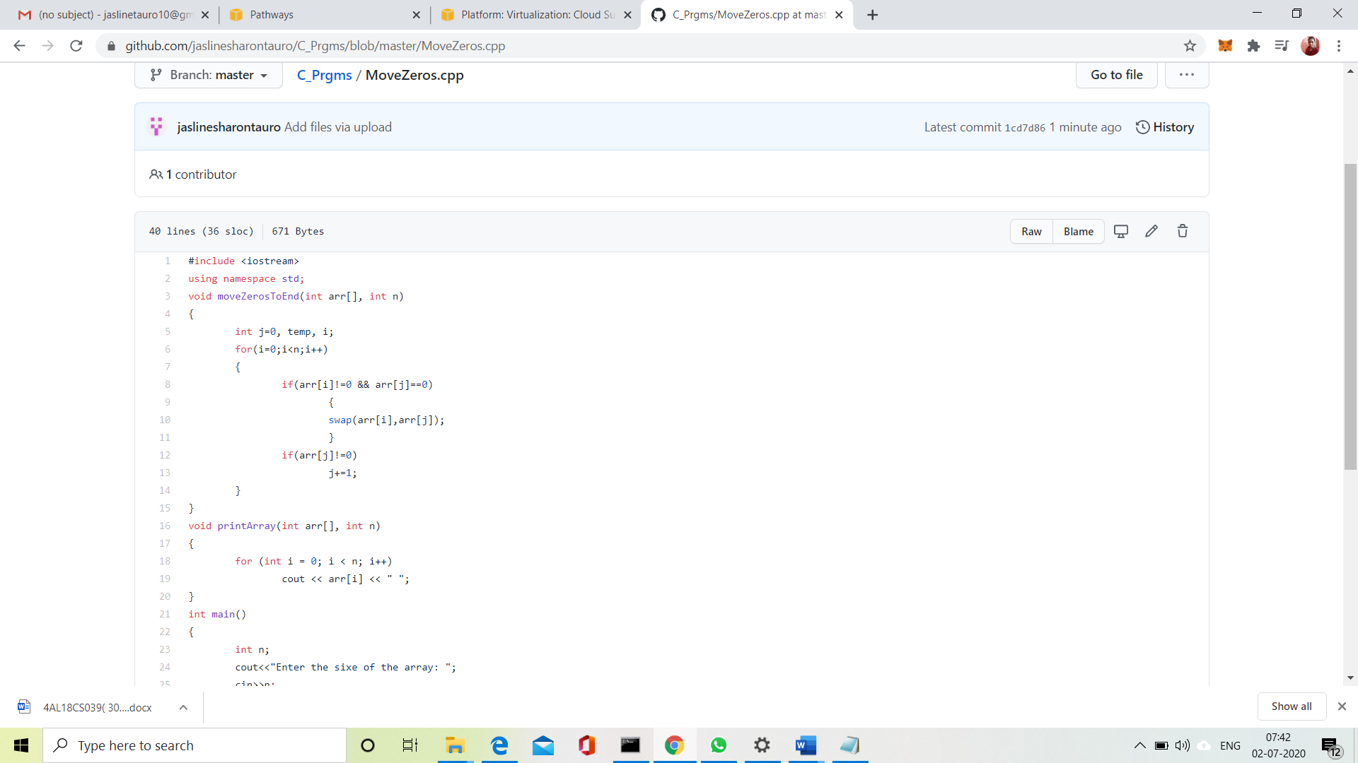

Solution Uploaded in GitHub.

Problem Statement 2:

Write a C Program to check whether the number is Ugly or not

Ugly numbers are those number whose prime factors are 2, 3 or 5. From 1 to 15, there are 11 ugly numbers 1, 2, 3, 4, 5, 6, 8, 9, 10, 12, 15. The numbers 7, 11, 13 are not ugly because they are prime. The number 14 is not ugly because in its prime factor the 7 will come.

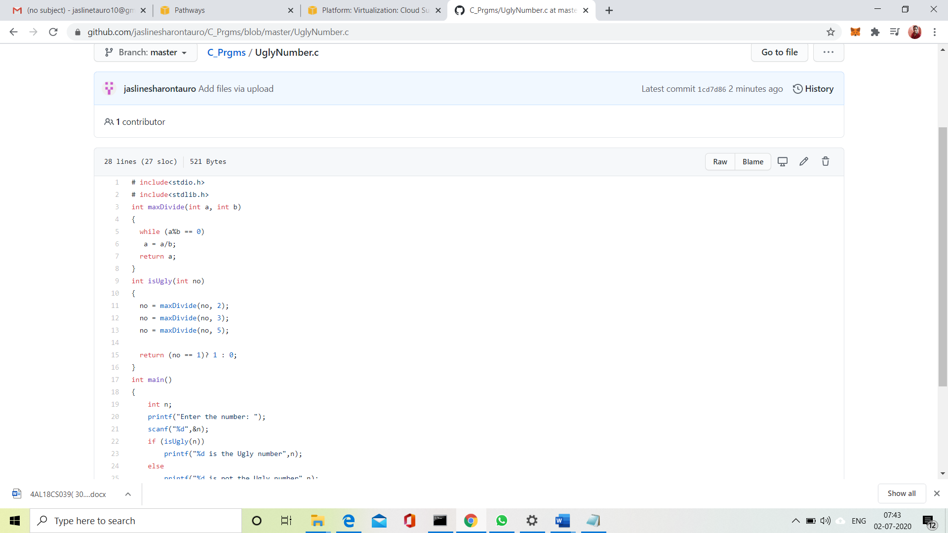

**Solution:** Uploaded it in GitHub

Problem Statement 3:

Write a C Program to generate first n Ugly Numbers

Ugly numbers are those number whose prime factors are 2, 3 or 5. From 1 to 15, there are 11 ugly numbers 1, 2, 3, 4, 5, 6, 8, 9, 10, 12, 15. The numbers 7, 11, 13 are not ugly because they are prime. The number 14 is not ugly because in its prime factor the 7 will come.

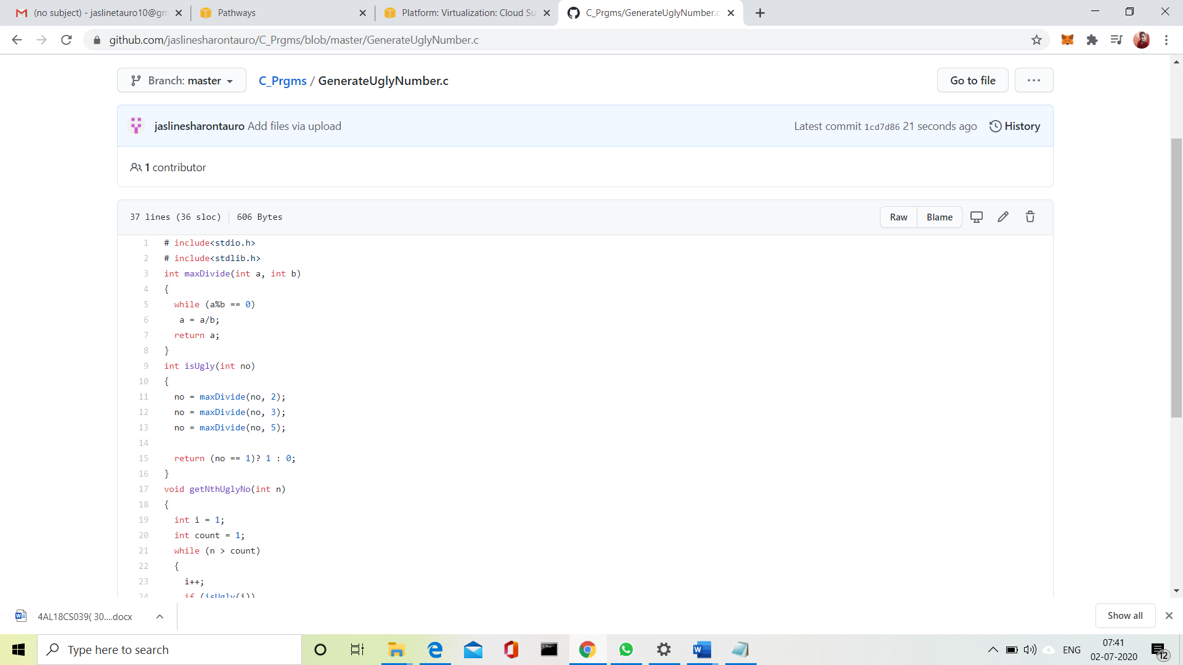

**Solution:** Uploaded it in GitHub